Par1:

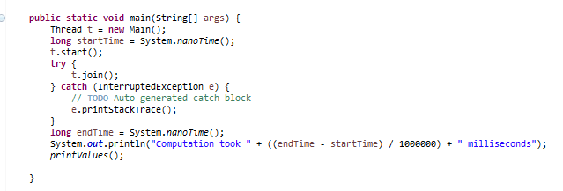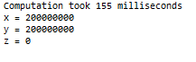

Part2:

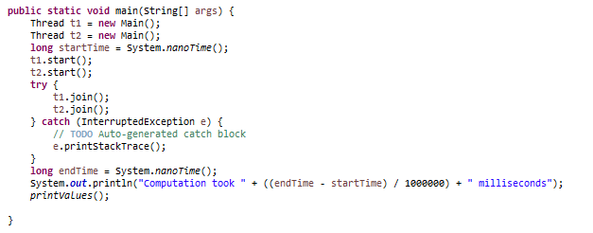

Part3:

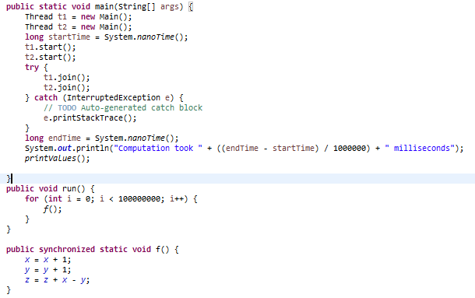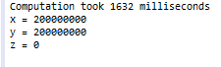

The fastest time for the computation was the one where there were two unsynchronized threads. The slowest was the two synchronized threads which was about 1600 ms slower.

Part4a:

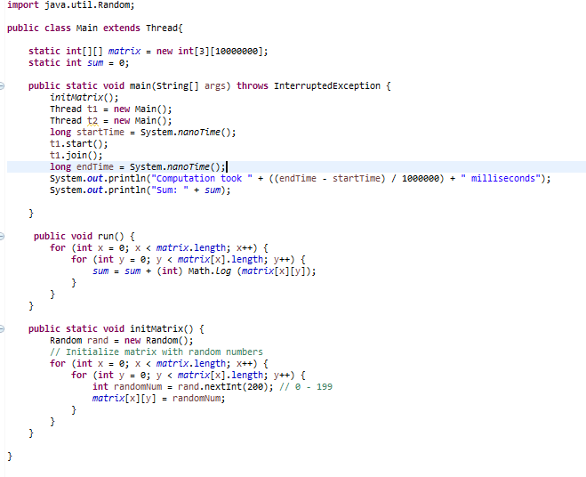



Part4b:

Here is a snapshot of the performance for different numbers of threads:

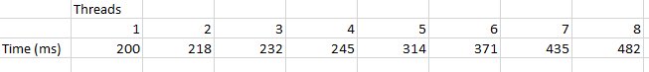

It seems like there is pretty significant slowdown in performance after 4 threads. This is probably explained by my processor (Intel-Core-i7-2640M) having 4 threads.